Opposite Sides
# Source: AI Source: Provided by: [Data Path: Persons Table -> ID Column: 1, Name_En Column: Motasem Essam] -> From: [ChatGPT] on [7/25/2026]
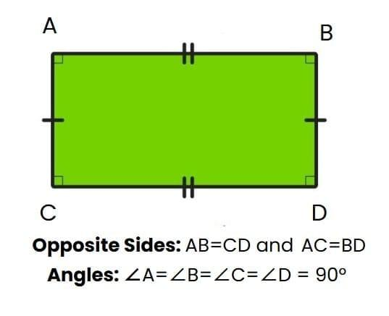
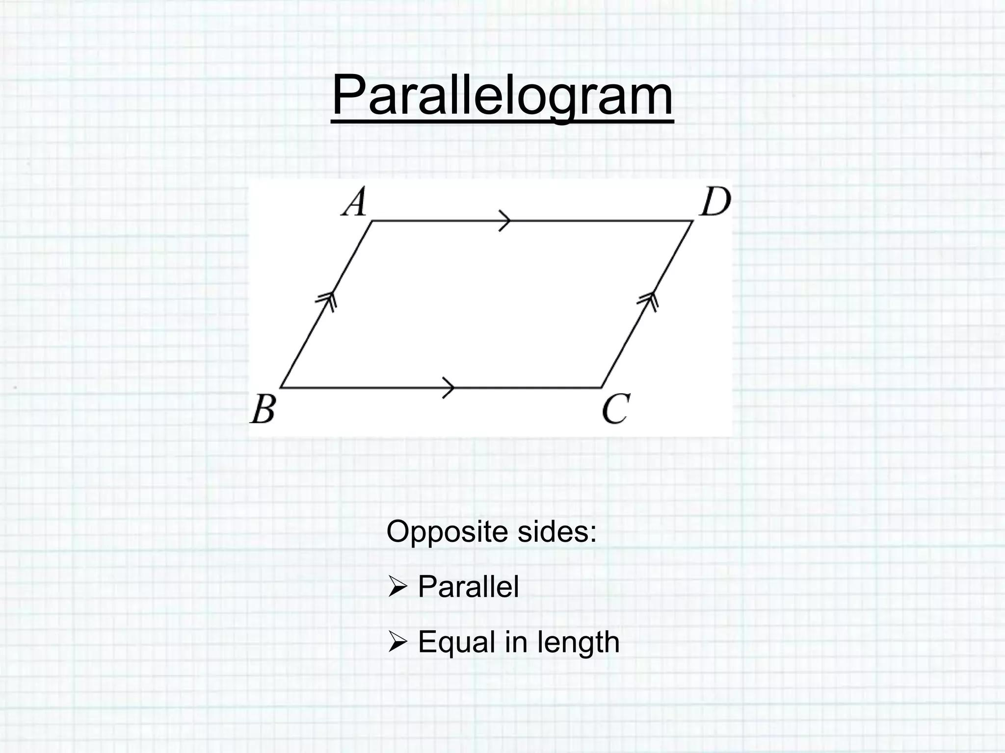
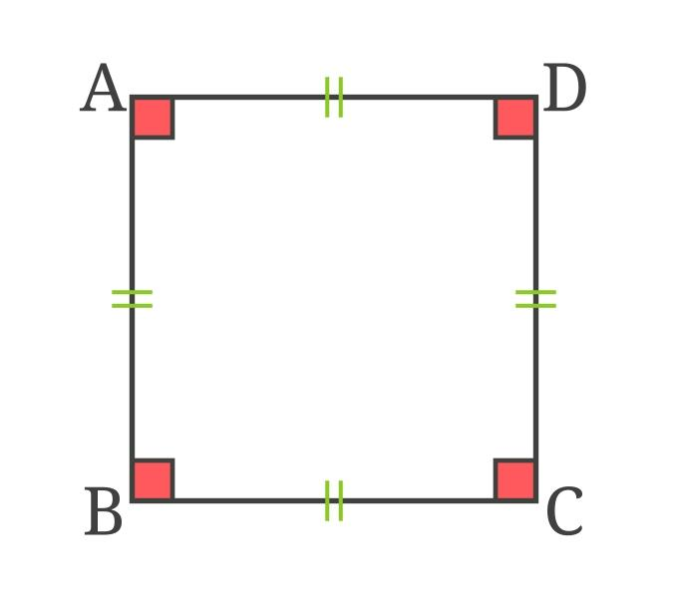
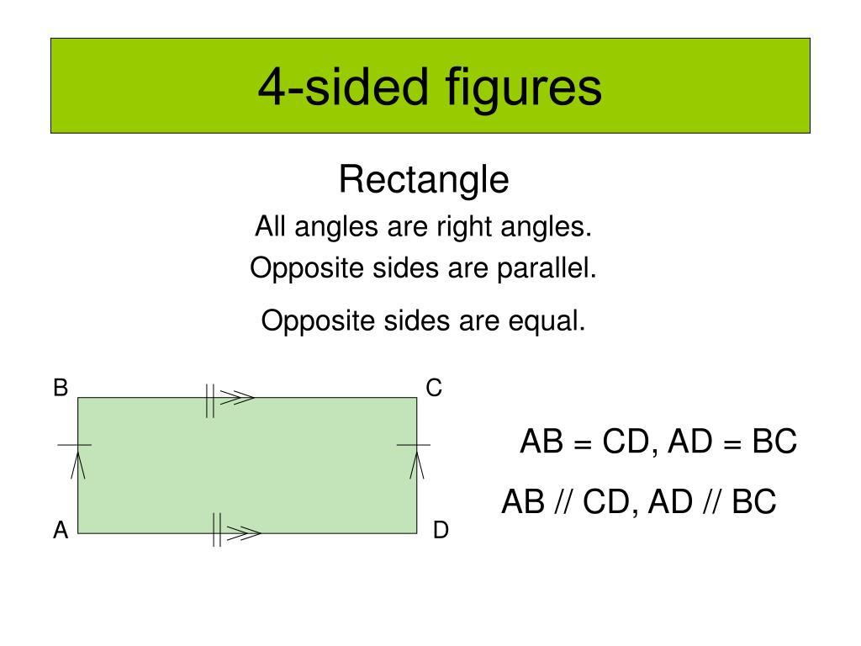
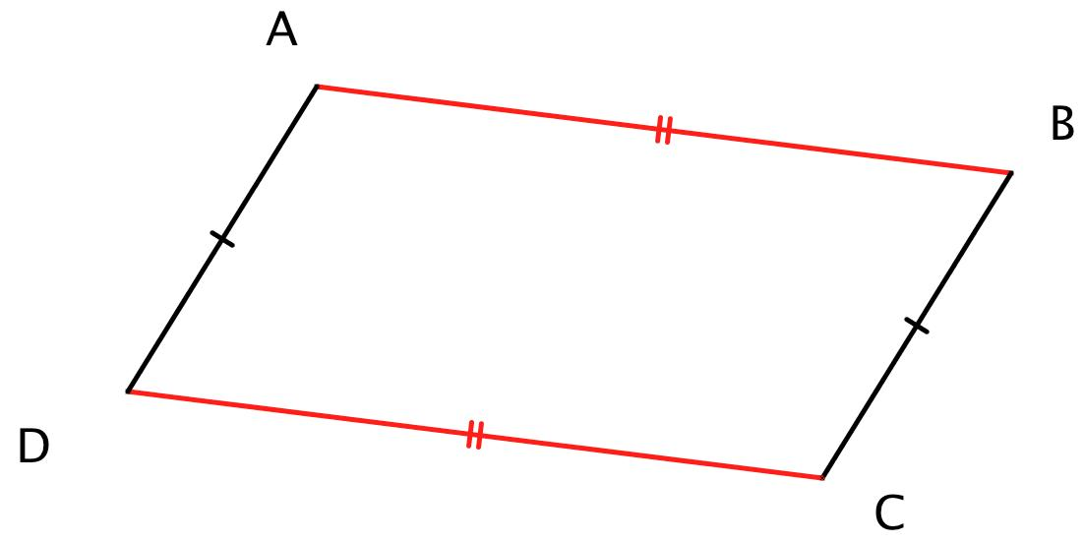

Definition
# Source: AI Source: Provided by: [Data Path: Persons Table -> ID Column: 1, Name_En Column: Motasem Essam] -> From: [ChatGPT] on [7/25/2026]
Opposite Sides are two sides of a polygon that do not share a common vertex and lie across from each other. They are separated by other sides of the polygon rather than meeting at a corner.
The concept of opposite sides applies mainly to polygons with four or more sides. A triangle does not have opposite sides because every pair of sides shares a vertex.

Characteristics
# Source: AI Source: Provided by: [Data Path: Persons Table -> ID Column: 1, Name_En Column: Motasem Essam] -> From: [ChatGPT] on [7/25/2026]
Opposite sides:
- Do not share a common vertex.
- Lie across from one another.
- Usually occur in polygons with at least four sides.
- May be equal or unequal.
- May be parallel or non-parallel depending on the shape.

Illustration

Rectangle
# Source: AI Source: Provided by: [Data Path: Persons Table -> ID Column: 1, Name_En Column: Motasem Essam] -> From: [ChatGPT] on [7/25/2026]
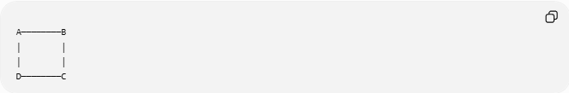
A────────B
│ │
│ │
D────────C
Opposite side pairs:
- AB and CD
- BC and AD

Parallelogram
# Source: AI Source: Provided by: [Data Path: Persons Table -> ID Column: 1, Name_En Column: Motasem Essam] -> From: [ChatGPT] on [7/25/2026]
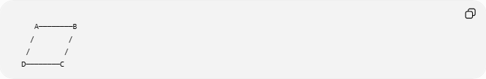
A────────B
/ /
/ /
D────────C
Opposite side pairs:
- AB and CD
- BC and AD

Mathematical Representation
# Source: AI Source: Provided by: [Data Path: Persons Table -> ID Column: 1, Name_En Column: Motasem Essam] -> From: [ChatGPT] on [7/25/2026]
For a quadrilateral
$$ABCD$$
the opposite sides are:
$$\overline{AB} \text{and} \overline{CD}$$
$$\overline{BC} \text{and} \overline{DA}$$

Examples
# Source: AI Source: Provided by: [Data Path: Persons Table -> ID Column: 1, Name_En Column: Motasem Essam] -> From: [ChatGPT] on [7/25/2026]
Example 1 – Rectangle
Properties:
$$\overline{AB}=\overline{CD}$$
$$\overline{BC}=\overline{DA}$$
and
$$AB∥CD$$
$$BC∥AD$$

Example 2 – Square
A square has:
- Equal opposite sides.
- Parallel opposite sides.

Example 3 – Trapezoid
A trapezoid has opposite sides, but generally only one pair is parallel.

Properties
# Source: AI Source: Provided by: [Data Path: Persons Table -> ID Column: 1, Name_En Column: Motasem Essam] -> From: [ChatGPT] on [7/25/2026]
1. No Common Vertex
Opposite sides never meet at the same corner.

2. Parallel in Some Shapes
In:
- Squares
- Rectangles
- Parallelograms
- Rhombuses
opposite sides are parallel.

3. Equal in Some Shapes
In:
- Rectangle
- Square
- Parallelogram
- Rhombus
opposite sides are equal in length.

4. May Be Unequal
In irregular quadrilaterals, opposite sides may have different lengths.

Triangle Exception
# Source: AI Source: Provided by: [Data Path: Persons Table -> ID Column: 1, Name_En Column: Motasem Essam] -> From: [ChatGPT] on [7/25/2026]
A triangle does not have opposite sides because each side shares a vertex with the other two sides.
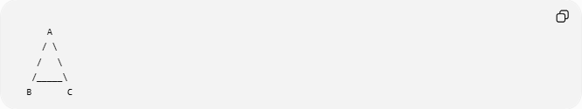
A
/ \
/ \
/_____\
B C
Every pair of sides is adjacent.

Real-World Examples
# Source: AI Source: Provided by: [Data Path: Persons Table -> ID Column: 1, Name_En Column: Motasem Essam] -> From: [ChatGPT] on [7/25/2026]
Opposite sides appear in:
- Doors.
- Windows.
- Picture frames.
- Books.
- Tables.
- Whiteboards.
- TV screens.
- Smartphone screens.
- Brick walls.
- Building façades.

Applications
# Source: AI Source: Provided by: [Data Path: Persons Table -> ID Column: 1, Name_En Column: Motasem Essam] -> From: [ChatGPT] on [7/25/2026]
Opposite sides are used in:
- Plane Geometry
- Coordinate Geometry
- Engineering
- Architecture
- Surveying
- CAD (Computer-Aided Design)
- Computer Graphics
- Robotics
- Industrial Design

Advantages
# Source: AI Source: Provided by: [Data Path: Persons Table -> ID Column: 1, Name_En Column: Motasem Essam] -> From: [ChatGPT] on [7/25/2026]
Studying opposite sides helps to:
- Classify quadrilaterals.
- Identify parallel relationships.
- Compute missing lengths.
- Solve congruence problems.
- Analyze geometric properties.

Limitations
# Source: AI Source: Provided by: [Data Path: Persons Table -> ID Column: 1, Name_En Column: Motasem Essam] -> From: [ChatGPT] on [7/25/2026]
The concept of opposite sides:
- Does not apply to triangles.
- Becomes more complex in polygons with many sides, where multiple non-adjacent side pairs exist.

Comparison with Related Concepts
# Source: AI Source: Provided by: [Data Path: Persons Table -> ID Column: 1, Name_En Column: Motasem Essam] -> From: [ChatGPT] on [7/25/2026]
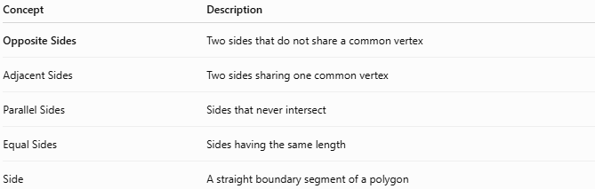
Concept | Description
Opposite Sides | Two sides that do not share a common vertex
Adjacent Sides | Two sides sharing one common vertex
Parallel Sides | Sides that never intersect
Equal Sides | Sides having the same length
Side | A straight boundary segment of a polygon

Key Points
# Source: AI Source: Provided by: [Data Path: Persons Table -> ID Column: 1, Name_En Column: Motasem Essam] -> From: [ChatGPT] on [7/25/2026]
- Opposite Sides lie across from each other.
- They do not share a common vertex.
- They exist in polygons with four or more sides.
- In many quadrilaterals, opposite sides are:
  - Equal.
  - Parallel.
- Triangles do not have opposite sides.

Conclusion
# Source: AI Source: Provided by: [Data Path: Persons Table -> ID Column: 1, Name_En Column: Motasem Essam] -> From: [ChatGPT] on [7/25/2026]ca
Opposite Sides are pairs of sides in a polygon that lie across from one another without sharing a common vertex. They are especially important in quadrilaterals such as rectangles, squares, parallelograms, and rhombuses, where they often exhibit properties such as equality and parallelism. The study of opposite sides is fundamental in plane geometry, coordinate geometry, engineering, architecture, surveying, CAD, computer graphics, robotics, and industrial design, where it helps classify figures, analyze geometric relationships, and solve measurement problems.

